GAME DESCRIPTION
Pinata Beat 1000



GAME INTRODUCTION
- THIS IS A 5-REEL SLOT GAME WITH 20 FIXED PAYLINES.

PAYTABLE
- ALL WINNING SYMBOLS PAY FROM LEFT TO RIGHT ON SELECTED PAYLINES.
- ONLY THE HIGHEST WIN IS PAID ON EACH PAYLINE.
- WHEN WINNING ON MULTIPLE PAYLINES, ALL WINS ARE ADDED TO THE TOTAL WIN.
- [WW] SUBSTITUTES FOR ALL SYMBOLS EXCEPT [Scatter].
- WHEN ALL CASCADES ARE COMPLETE, 3 OR MORE [C1] ON THE FINAL REELS WILL TRIGGER THE FREE GAME FEATURE.
- PAY TABLE
[M1] 5 - 5000 | [M2] 5 - 2000 | [M3] 5 - 1000
[M1] 4 - 1250 | [M2] 4 - 500 | [M3] 4 - 250
[M1] 3 - 250 | [M2] 3 - 100 | [M3] 3 - 75
[M4] 5 - 750 | [M5] 5 - 500 | [A] 5 - 250
[M4] 4 - 200 | [M5] 4 - 100 | [A] 4 - 50
[M4] 3 - 50 | [M5] 3 - 25 | [A] 3 - 10
[K] 5 - 250 | [Q] 5 - 250 | [J] 5 - 250
[K] 4 - 50 | [Q] 4 - 50 | [J] 4 - 50
[K] 3 - 10 | [Q] 3 - 10 | [J] 3 - 10

CASCADING FEATURE
- AFTER EACH WIN EVALUATION, WINNING SYMBOLS ARE REMOVED AND THE SYMBOLS ABOVE FALL DOWN TO FILL THE EMPTY POSITIONS.
- DURING CASCADING, IF A REEL ALREADY CONTAINS 1 [Scatter], NO MORE [Scatter] WILL APPEAR ON THAT REEL.
- AFTER THE SYMBOLS CASCADE DOWN, NEW WINNING COMBINATIONS ARE EVALUATED AGAIN. THIS PROCESS REPEATS UNTIL NO NEW WINNING COMBINATIONS ARE FORMED.

MULTIPLIER FEATURE
- GOLD FRAMED SYMBOLS MAY CARRY A MULTIPLIER VALUE. THE MULTIPLIER LEVELS ARE: X2, X3, X5, X8, X10, X15, X20, X25, X50, X100, X500, AND X1000.
- THE MULTIPLIER IS ONLY COLLECTED AND ADDED TO THE ACCUMULATED TOTAL WHEN THE GOLD FRAMED SYMBOL WITH A MULTIPLIER ACTUALLY PARTICIPATES IN A WIN AND IS CLEARED.
- WHEN NO MORE CASCADES CAN OCCUR, IF ANY MULTIPLIER WAS COLLECTED DURING THIS SPIN, THE TOTAL ACCUMULATED MULTIPLIER IS APPLIED TO THE TOTAL WIN OF THIS SPIN.

GOLDEN FRAMED FEATURE
- GENERAL SYMBOLS ON REELS 2, 3, AND 4 MAY APPEAR WITH A GOLD FRAME.
- GOLD FRAMED SYMBOLS PAY THE SAME AS THEIR ORIGINAL SYMBOLS.
- IN THE BASE GAME, REEL 3 MAY RANDOMLY APPEAR AS AN ENTIRE REEL OF GOLD FRAMED SYMBOLS WITH MULTIPLIERS.
- IF THE PREVIOUS WINNING COMBINATION INCLUDES A GOLD FRAMED SYMBOL, THAT POSITION REMAINS ON THE REELS AND CHANGES INTO [WW], SO IT IS NOT TREATED AS AN EMPTY POSITION.

FREE GAME FEATURE
- WHEN ALL CASCADES ARE COMPLETE, IF THE FINAL REELS SHOW 3, 4, OR 5 [C1], THE FREE GAME FEATURE IS TRIGGERED WITH 15, 17, OR 19 FREE SPINS RESPECTIVELY.
- DURING FREE GAME, THE ACCUMULATED MULTIPLIER IS NOT RESET BETWEEN SPINS AND IS CARRIED OVER UNTIL THE ENTIRE FREE GAME ENDS.
- DURING FREE GAME, GENERAL SYMBOLS ON REEL 3 ARE GUARANTEED TO APPEAR WITH GOLD FRAMES AND MULTIPLIERS.
- AFTER ENTERING THE FREE GAME, INCLUDING RETRIGGERING, THE MAXIMUM NUMBER OF FREE SPINS IS 50.
- FREE GAME CAN BE RETRIGGERED. RETRIGGERING FOLLOWS THE SAME CONDITIONS: 3, 4, OR 5 [C1] WILL ADD 15, 17, OR 19 FREE SPINS RESPECTIVELY.

EXTRA BET
- THE PLAYER MAY SELECT THE EXTRA BET MODE.
- EXTRA BET USES THE SAME BASE GAME, CASCADING, AND FREE GAME FLOW.
- EXTRA BET COSTS 2X TOTAL BET AND INCREASES THE CHANCE TO TRIGGER THE FREE GAME FEATURE.

BUY FEATURE
- BUY FEATURE CAN BE PURCHASED BY USING A VALUE EQUAL TO 75X TOTAL BET.
- PURCHASING THE FREE GAME FEATURE GUARANTEES FREE GAME.
- WINS FROM THE TRIGGER SPIN ARE KEPT AND PAID TOGETHER WITH THE TOTAL WIN FROM THE FREE GAME FEATURE.

OP JACKPOT
- OP JACKPOT FEATURE IS TRIGGERED RANDOMLY BY 1 OR MORE [C1] ON THE REELS.
- DURING OP JACKPOT FEATURE, THERE ARE {12} [COIN] WHICH CONSIST OF [GRAND], [MAJOR], [MINOR] AND [MINI].
- SELECT A [COIN] TO REVEAL [GRAND], [MAJOR], [MINOR], OR [MINI]. IF PLAYER GETS {3} SAME JACKPOT SYMBOLS WILL WIN THE JACKPOT AND CALCULATE TOTAL WINNINGS.
- [GRAND] IS LINKED PROGRESSIVE JACKPOT. IF THE SINGLE GAME BET OPTION IS 2.00 OR ABOVE, THE PLAYER WILL UNLOCK [GRAND].
- [MAJOR] IS LINKED PROGRESSIVE JACKPOT. IF THE SINGLE GAME BET OPTION IS 2.00 OR ABOVE, THE PLAYER WILL UNLOCK [MAJOR].
- [MINOR] WILL CHANGE IF THE PLAYER SELECTS DIFFERENT BET OPTION.
- [MINI] WILL CHANGE IF THE PLAYER SELECTS DIFFERENT BET OPTION.
- THE HIGHER THE PLAYER BETS, THE HIGHER THE CHANCE TO TRIGGER THE OP JACKPOT FEATURE.

LINE GAME
- THE GAME HAS 20 FIXED PAY LINES.
- WINNING COMBINATIONS MUST START FROM THE LEFTMOST REEL AND RUN CONSECUTIVELY FROM LEFT TO RIGHT.
- ONLY THE HIGHEST WIN PER PAY LINE IS PAID.
- PLEASE REFER TO THE PAYLINE DIAGRAM FOR THE 20 FIXED PAY LINE PATTERNS.
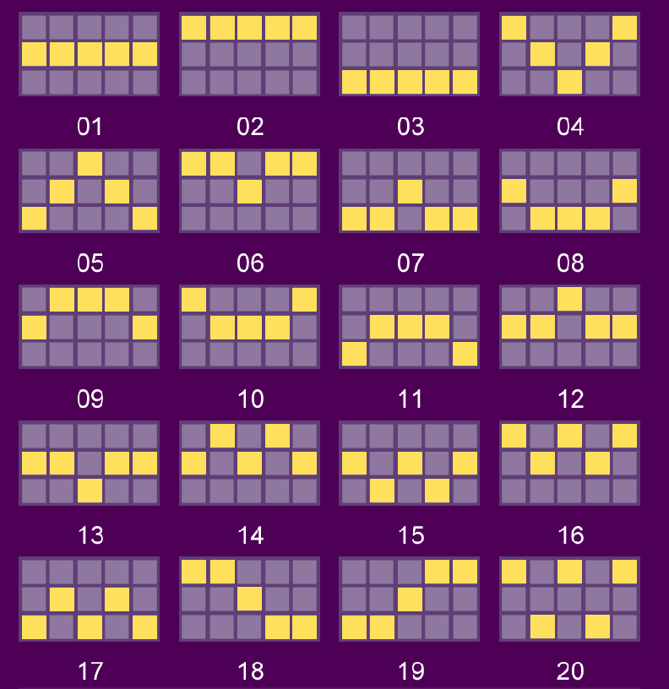

GAME RULE
- SELECT BET OPTION YOU WISH TO PLAY.
- ALL WINS ARE MULTIPLIED BY BET OPTION EXCEPT PROGRESSIVES BONUSES.
- MALFUNCTION VOIDS ALL PAYS AND PLAYS.
- IF THE PLAYER LOSES CONNECTION DURING THE FREE GAME FEATURE, THE SYSTEM WILL CALCULATE THE GAME RESULTS AUTOMATICALLY AND THE WINNING PRIZES WILL BE ADDED INTO THE BALANCE.

